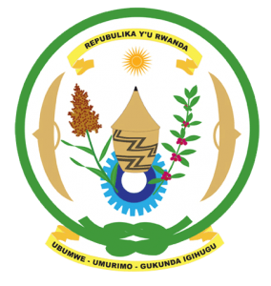
27th Session of the Universal Periodic Review Working Group
Review of Finland
03rd May 2017
Statement by Rwanda delivered by Mr. Moses Rugema
Thank you Mr. President,
- Rwanda welcomes the delegation of Finland and thank them for the presentation of their third cycle national report and the oral update just provided.
- Rwanda welcomes Finland’s continued efforts to promote and protect human rights including through implementation of its second National Action Plan on Human Rights.
- We welcome Finland’s efforts to combat discrimination, hate speech and related intolerance. In that regard, we have one question and one recommendation:

- As part of its efforts to combat discrimination, has Finland undertaken an assessment of potential risk factors of atrocity crimes with a view to their prevention?
- We recommend that Finland consider including in its next UPR report, information on measures it has taken to analyse potential risk factors of atrocity crimes including through utilisation of the Framework of Analysis for Atrocity Crimes.
We wish Finland every success in the implementation of the recommendations of this UPR.
Thank you

